University of Washington

iSchool Info 330

# Final

In this Final, you will **plan, document, and implement a database** used for an application being created by another development team.

## The Application

The purposed application consists of a simple Windows application that **handles scheduling of appointments between patients and doctors**.

This application allows a user to:

* Search for **existing** **patients**
* Add a **new** **patient**
* Search for **doctor**
* Select a **clinic**
* Select an **appointment** date and time

## Application Flow

Users will use the application in this manner (Figure 1).

1. User **looks up an existing** patient (If patient cannot be found a new record can be created).

2. User **selects a doctor** (or clinic)

3. User **selects a clinic** (or doctor)

4. User **selects a date and time** for the appointment

5. User **Creates the appointment** (or updates appointment or delete appointment)

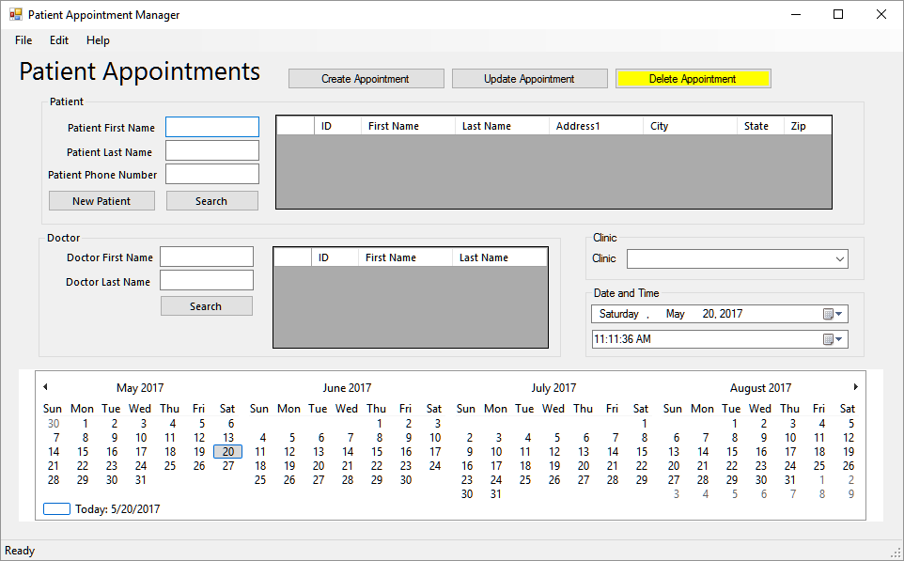

**Figure 1: The Patient Appointment Manager**

## Database Design

You need to **design a database** based on what you’ve know about the application. This database will be a **prototype**, so it is expected that there to be issues to resolve later, but you will try to get as close to a final design as you can. When you find issues, or have question for the Application team, you will to note these for discussion once your prototype design is complete.

Please remember to **use normalization, constraints, and abstraction layers**. Each table needs a view showing the table's data and an insert, update, and delete stored procedure. All stored procedures must have explicit transactions and error handling and of course test code at the bottom of the script.

## Project Artifacts

You need to turn in the **developer document** in Excel, the **ERD**, the **SQL script** that creates the database, the **SQL Import script** that fills your database with sample data, an **Excel, Tableau, and PowerBI Report**, a formal **project document** that details the final database design, and your **lessons learned document**.

Here is an outline of these items and the points associated with them.

|  |  |  |  |  |
| --- | --- | --- | --- | --- |
| **Final Checklist** | |  |  |  |
| Max Points | Your Points | Project Component | Est Hours | Actual Hours |
|  |  | **Milestone 1 (Assignment 07: Design)** |  |  |
| 80 |  | A development documentation using MS Excel | 4 |  |
| 20 |  | An ERD | 1 |  |
|  |  | **Milestone 2 (Assignment 08: Implementation)** |  |  |
| 100 |  | A SQL database script (tables, constraints, views, etc.) | 4 |  |
|  |  | **Milestone 3 (Assignment 09: QA and Testing)** |  |  |
| 30 |  | An Import script of sample data | 2 |  |
| 10 |  | One or more reporting views | 1 |  |
| 20 |  | One or more Excel reports | 1 |  |
| 20 |  | One or more Tableau reports | 1 |  |
| 20 |  | One or more PowerBI reports | 1 |  |
|  |  | **Milestone 4 (Assignment 10: Documentation and Release)** |  |  |
| 80 |  | A formal project document using MS Word | 2 |  |
| 20 |  | Lessons Learned Document | 1 |  |
| **400** | **0** | **Total** | **18** |  |

**Milestone 01**

In this milestone, you **design a database** based on what you can guess about the application and its database needs. You will be graded on how well thought out your design is and how well you follow the rules of normalization. There are multiple correct answers, so you have lots of chances to get it “right!” Not, guessing the exact design I want you to will not affect the outcome of the final project, so don’t be concerned breaking the final if you do not get everything correct. Just try your best, think things though, **keep it simple, and be ready to defend the reasons for your design** when we ask you question during the grading process!

### Task 1

I have provided a starter Excel spreadsheet “***MetaData for Patient Appointment Project.xlsx***.” **Fill in the items** needed to describe your database design (Figure 1).

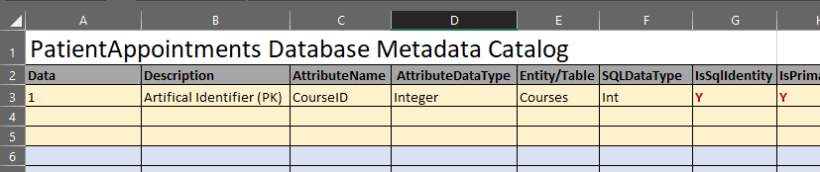

***Figure 1: The current metadata in the MetaData.xlsx file***

### Task 2

Afterwards, **create a Database Diagram** for your newly designed database. Here is an **incomplete and possible incorrect** example I created using PowerPoint and Word (Figure 2).

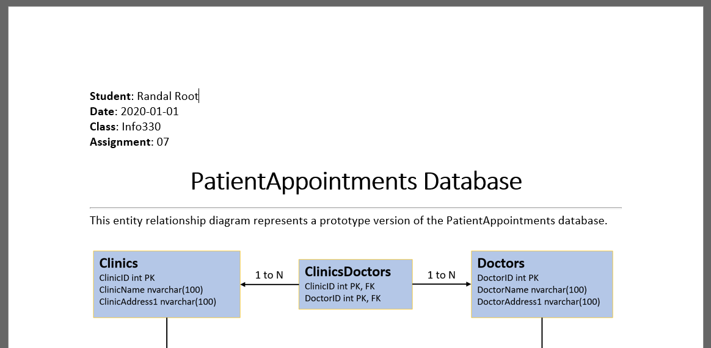

***Figure 2: The ERD in a Word document***

***Note:*** *Remember that**there are several ways this database can be designed. If your design similar examples you've seen and fits the rules of normalization, then you have done well.**Design it like you think it should be designed, but be prepared to explain why your answer is correct!*

You can use any tool you want to create the diagram, but once it is done, paste an image of it into a document for submission.

### Turing in your work

Turn in your completed **Excel metadata spreadsheet and the ERD** under Assignment 07.

**Milestone 02**

In this milestone, you create a prototype database and import some basic data into then new database.

### Task 1

Create a SQL script that implements a database as defined by an updated Excel development document (figure 3). The database will include tables, views, and stored procedures.

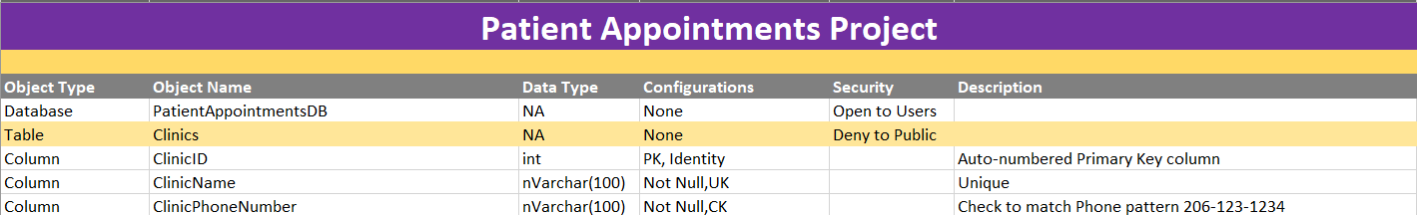

***Figure 3: The Updated Metadata Spreadsheet***

***Note:*** *Remember to use the metadata spreadsheet provided by your instructor and not your original design.*

### Turing in your work

**Turn in the script that creates the database under Assignment 08**.

**Milestone 03**

In this milestone you need to import some basic data, create one or more reporting views, and three reports. The reports should include one “table like” display of data and one chart. It must also include a Title and header with your name and the date similar to Figure 4.

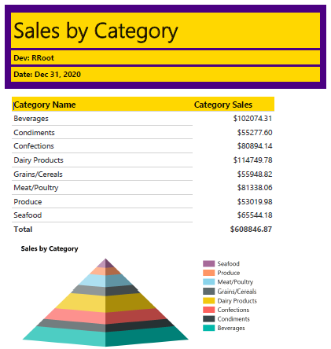

**Figure 4: The common format of a report**

### Task 1

You will also need to create a SQL script that fills the database with a new with some basic sample data. You only need a few patients, doctors, and clinics and you need to import those first and before adding a few appointments.

Add a minimum of:

* 5 clinics
* 10 Doctors
* 10 Patients
* 10 Appointments

You can either “Hard Code” the values, use Mocaroo.com to generate values, or use SQL code to generate values.

### Task 2

Create One or More Reporting Views. You should already have one reporting view in your database, called vAppointmentsByPatientsDoctorsAndClinics that shows data from all the tables, but create smaller one(s) to be used for your reports.

### Task 3

Create an Excel report using data from a view.

### Task 4

Create a Tableau report using data from a view. (See the important note below)

### Task 5

Create an Power BI report using data from a view.

***Note:*** *Your reports should give information to the user. They can be a simple, but I want you to think about what you are creating. Something like; which doctors are seeing which patients, which patients have appointment on which days, which doctors are at which clinics on which dates are all acceptable examples.*

### Turing in your work

**Turn in your script that imports some basic data, a script that creates the reporting views, and the three report files under Assignment 09.**

***Important: Tableau, no longer lets you save a local file to a folder, so capture a screenshot of your tableau report and paste it into a Word document called, "Tableau Report Example."***

**Milestone 04**

In this Milestone you have two tasks to perform. The first is the creation of a formal project development document for your solution that second is a lessons learned document.

### Task 1

I have provided you with a sample of a solution development planning (figure 5). You can you will need to **remove the existing entries** and **add your entries**, but it should provide you with a convenient format in which to enter in your project's meta-data.

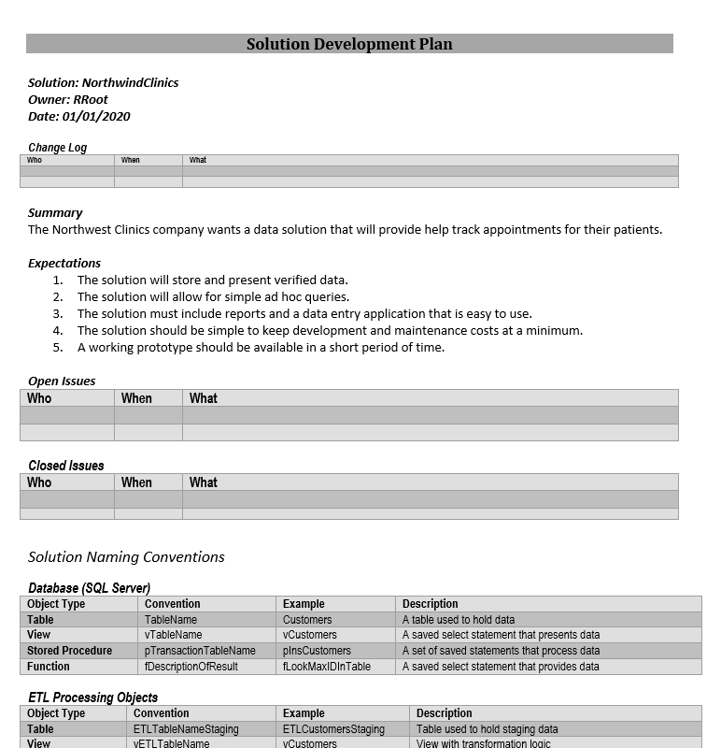

**Figure 5: The formal project documentation**

### Task 2

The **second task** requires that you create a **document** about the **lessons you have learned throughout this course**. This can be a **relatively informal overview** of the different things you have learned during the quarter. It does not have to be an exhaustive enumeration of these items but should include at least two or more different aspects of creating and working with a relational database.

This helps both you and I to understand your progress in this class. You may be surprised to see how this process also solidifies what you have learned (or at least other students have told me it does!) There is no need to make this an exhaustive coverage of what you did, so make the paper to about a single page of text and it will be fine.

### Turing in your work

Locate your previous work from the other milestones and place the files into the subfolders of the folder "Info330Project-YourNameHere" that I have provided for you (Figure 6). Place your new document into the Milestone 04 folder.

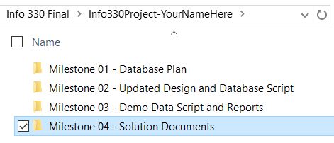

**Figure 06: The Info330Project-YourNameHere Final folder**

Once **all the files** are in the subfolders, Zip the Info330Project-YourNameHere folder and turn it in under Assignment 10.

## Grading

Student work will be evaluated on a point system using the following general guidelines found on the Course Syllabus page. Make sure you read and understand this.

**NOTE:**  It is very possible to get a 3.9 or better from this course, but you have to earn it! Do not expect to get 100% of the possible points without extra effort on your part. If you want to excel in this course, you must submit **excellent**work!